LAB EXPERIMENT
SET 19: SURVEY RESPONSES ANALYSIS
Department | AIDS
Course Code / Course Name | DSA0602 / Data Handling and Visualization
Experiment | Data Visualization using R and Tableau
Name | D.HEMASREE
Register Number | 192524114
Date | 13 October 2026
Day | Tuesday

Aim
To analyze survey response data using a grouped bar chart, a stacked bar chart and a response table in R, and to build an interactive dashboard using Tableau. Dataset: Survey Responses
Survey ID | Question 1 | Question 2 | Question 3
1 | A | B | C
2 | B | A | D
3 | C | A | B

PROGRAM 1: Grouped Bar Chart for Question 1
Create a grouped bar chart to visualize the distribution of answers for Question 1. Label the chart elements.
# Dataset (rows = surveys, columns = answer options)
q1_matrix <- rbind(
"Survey 1" = c(1, 0, 0, 0),
"Survey 2" = c(0, 1, 0, 0),
"Survey 3" = c(0, 0, 1, 0)
)
colnames(q1_matrix) <- c("A", "B", "C", "D")

# Grouped Bar Chart
barplot(q1_matrix,
beside = TRUE,
col = c("steelblue", "darkorange", "forestgreen"),
xlab = "Answer Option",
ylab = "Number of Responses",
main = "Question 1: Distribution of Answers",
legend.text = rownames(q1_matrix),
args.legend = list(x = "topright", title = "Survey ID"),
ylim = c(0, 2))

OUTPUT:
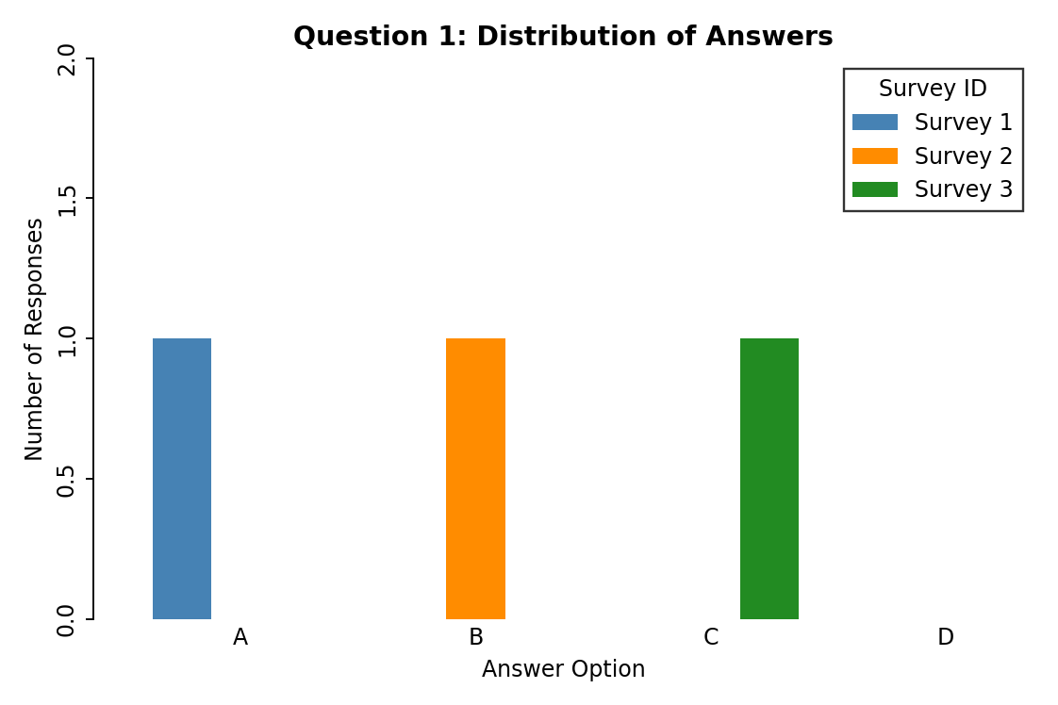
Output 1: Question 1 Answer Distribution (Grouped Bar Chart)
Observation:
Question 1 received three different answers. Option A was chosen in Survey 1, option B in Survey 2 and option C in Survey 3, so each of these options has one response (about 33% each). Option D was not chosen by any survey.

PROGRAM 2: Stacked Bar Chart of Overall Responses
Generate a stacked bar chart to represent the overall distribution of responses for all three questions.
# Dataset (rows = answer options, columns = questions)
responses <- cbind(
"Question 1" = c(1, 1, 1, 0),
"Question 2" = c(2, 1, 0, 0),
"Question 3" = c(0, 1, 1, 1)
)
rownames(responses) <- c("A", "B", "C", "D")

# Stacked Bar Chart
barplot(responses,
col = c("steelblue", "darkorange", "forestgreen", "firebrick"),
xlab = "Question",
ylab = "Number of Responses",
main = "Overall Distribution of Responses",
legend.text = rownames(responses),
args.legend = list(x = "topright", title = "Answer"),
ylim = c(0, 4))

OUTPUT:
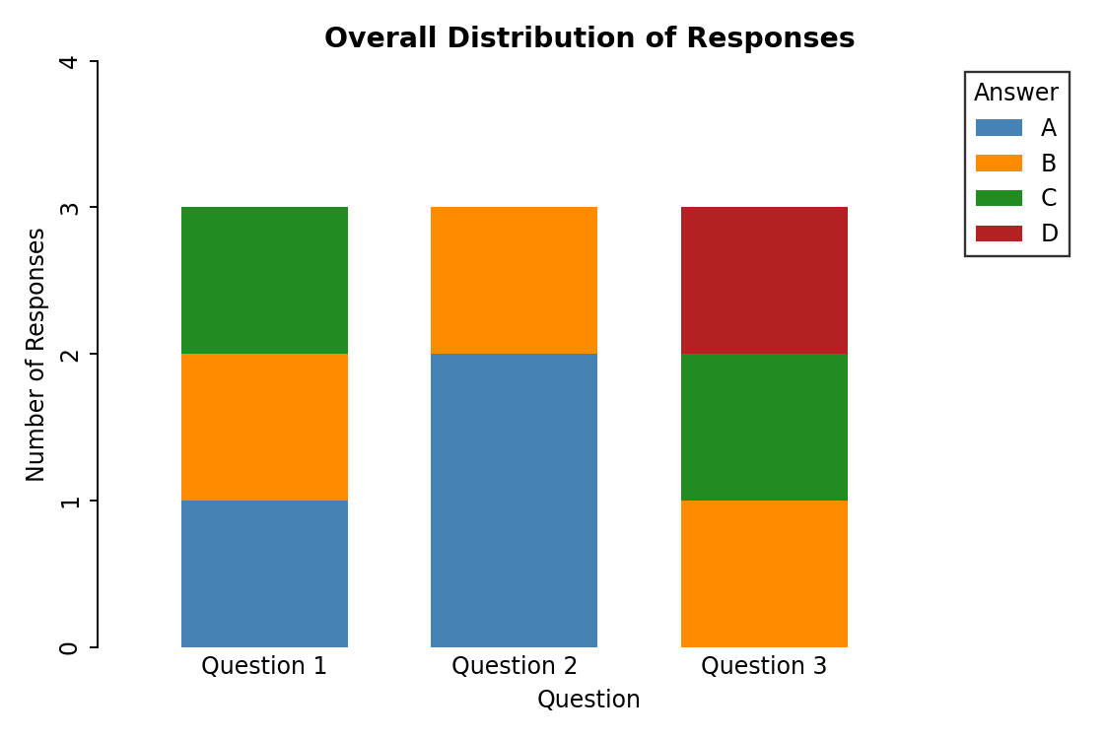
Output 2: Overall Distribution of Responses (Stacked Bar Chart)
Observation:
All three questions have 3 responses, so the stacked bars are equal in height. Option A was chosen twice in Question 2, the only answer repeated within a question. Option B appears once in every question and option D appears only once, in Question 3. Across all 9 answers, A and B are chosen 3 times each, C twice and D once.

PROGRAM 3: Table of Survey Responses
Build a table to show the survey response data for each survey. Label the table elements.
# Dataset
survey <- data.frame(
Survey_ID = 1:3,
Question_1 = c("A", "B", "C"),
Question_2 = c("B", "A", "A"),
Question_3 = c("C", "D", "B")
)

# Display the table
print(survey)

# Count of each answer across all questions
table(unlist(survey[, -1]))

Console Output
Survey_ID Question_1 Question_2 Question_3
1 1 A B C
2 2 B A D
3 3 C A B

A B C D
3 3 2 1
Output 3a: Survey Response Table (R Console)
Survey ID | Question 1 | Question 2 | Question 3
1 | A | B | C
2 | B | A | D
3 | C | A | B
Output 3b: Survey Response Table with Labelled Elements
Observation:
The table gives the exact answer of each survey to every question. Surveys 2 and 3 both answered A for Question 2, while Survey 1 answered B. No two surveys gave the same set of answers. The answer counts (A = 3, B = 3, C = 2, D = 1) match the stacked bar chart.

PROGRAM 4: Interactive Survey Responses Dashboard in Tableau
Develop a Tableau dashboard combining the grouped bar chart, stacked bar chart and the table for interactive exploration of survey responses.
Steps in Tableau
- Save the data as an Excel or CSV file and connect to it in Tableau (Connect > Microsoft Excel / Text file). Select the Question 1, Question 2 and Question 3 columns, right-click and choose Pivot, then rename the new fields to "Question" and "Answer". Right-click Survey ID and choose Convert to Dimension.
- Sheet 1 (Grouped Bar Chart): Drag Question to Filters and keep only Question 1. Drag Answer and then Survey ID to Columns, and Number of Records to Rows (SUM). Drag Survey ID to Color and add Number of Records to Label. Rename the sheet "Question 1 Distribution".
- Sheet 2 (Stacked Bar Chart): Drag Question to Columns and Number of Records to Rows (SUM). Drag Answer to Color so that each bar is stacked by answer option. Rename the sheet "Overall Responses".
- Sheet 3 (Table): Drag Survey ID to Rows, Question to Columns and Answer to Text. Rename the sheet "Response Table".
- Create a new Dashboard (Dashboard > New Dashboard), set the size to Automatic, and drag the three sheets onto the dashboard area.
- Add interactivity: select each chart and click Use as Filter, so clicking an answer or a question in one view filters the others. Add Survey ID and Question filters (Show Filter > Apply to Worksheets > All Using This Data Source).
- Add the title "Survey Responses Dashboard" and test the filters in Presentation Mode.

OUTPUT:
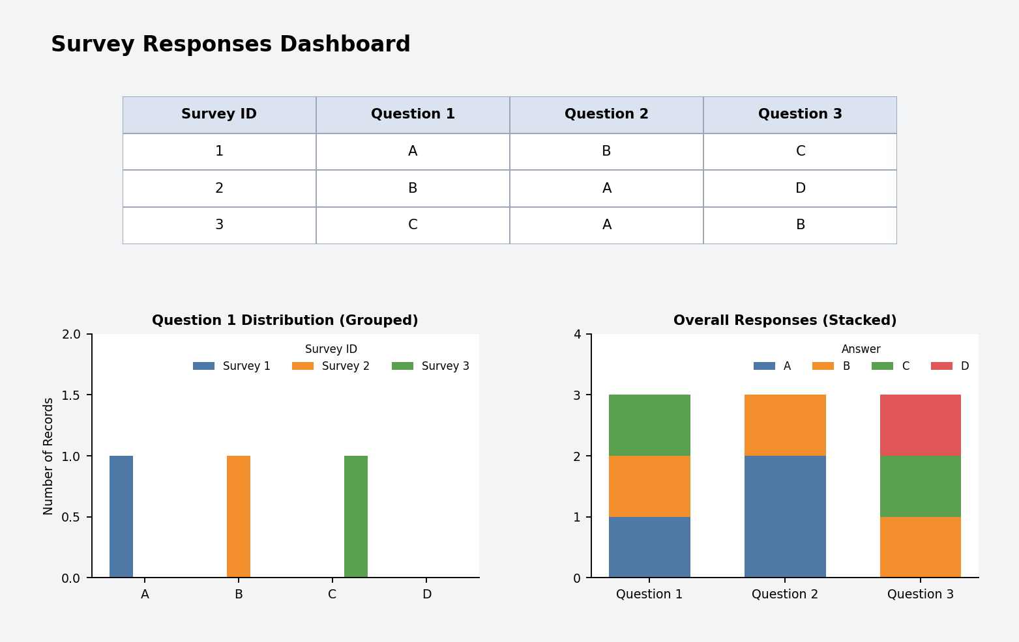
Output 4: Interactive Survey Responses Dashboard (Tableau)
Observation:
The dashboard shows the Question 1 answer distribution, the overall response distribution and the response table together. Clicking an answer or a question in one view filters the other views.

Procedure
- Define the survey responses in R as count matrices and a data frame.
- Use barplot() with beside = TRUE to create the grouped bar chart for Question 1.
- Arrange the answer counts of all questions in a matrix and use barplot() to draw the stacked bar chart.
- Create a data frame of the survey responses and display it with print() and table().
- Load the survey file into Tableau, pivot the question columns, and build the grouped bar chart, stacked bar chart and table worksheets.
- Combine the worksheets in a Tableau dashboard and add filters and actions for interactivity.

RESULT:
The survey response data was successfully analyzed using a grouped bar chart, a stacked bar chart and a response table in R. An interactive Tableau dashboard was also created, combining all three views so that users can explore the survey responses by question and by answer.

Key Functions and Tools Used
Function / Tool | Purpose
rbind() / cbind() / data.frame() | Creates the response matrices and the survey table.
barplot(beside = TRUE) | Creates the grouped bar chart.
barplot() | Creates the stacked bar chart from the count matrix.
print() / table() | Displays the survey table and counts each answer.
Tableau Pivot | Converts the question columns into Question and Answer fields.
Tableau Dashboard | Combines worksheets with filters and actions.

